Accessing the Simplybook Booking Platform for managing the Covid 19 Vaccination Appointments
To support the Covid-19 vaccination delivery
Contents
1 Definition and Purpose 3
2 Preparing to Use the JBS Booking Platform 3
2.1 Requesting access for new users 3
2.2 Download the Simply Book App onto Mobile device 3
3 Accessing the Simplybook Online Booking System – Admin Interface 3
3.1 New User Email Notification 3
3.2 Setting a New Password 3
3.3 Log In Success 4
3.4 Log Out 4
4 Accessing the Simplybook App for the First time 4
4.1 Accessing the app 4
4.2 Log In Success 5
4.3 Log Out 5
5 Points to consider 5
5.1 Selecting the most appropriate interface 5
5.2 Requesting a password reset 5
5.3 Remember to Log out of the System 5

- Definition and Purpose
This booklet sets out the operational processes for accessing the Simplybook vaccination appointment online booking platform to support the Covid-19 vaccination delivery.
Should you not be able to find the support you require within this document, please contact the jbs.enquiries@miaa.nhs.uk mailbox, where one of the team will be able to assist.
- Preparing to Use the JBS Booking Platform
  - Requesting access for new users
To request access for new users, please contact your clinic system administrator and provide the following information:
- Full Name
- Email Address
- Contact Mobile Number
- Type of access – i.e. Administrator, POS, Doorman, Viewer
Once actioned by the team, the new user will obtain an email with their joining instructions.
  - Download the Simply Book App onto Mobile device
If you intend to use the mobile app to support the function of Doorman, you will need to download the Simplybook.me app.
You can find the App in all the app stores. It is called ‘Simplybook.me’.
Download, as you would do any other application and await your login details.
- Accessing the Simplybook Online Booking System – Admin Interface
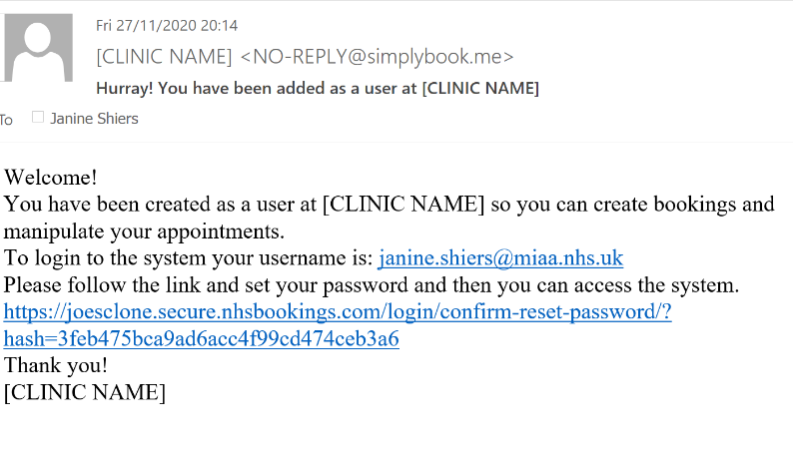
  - New User Email Notification
Once a user account has been created, you will be sent a notification to the email address provided to your clinic system administrator.
The email will confirm your username, and a link. The link is time sensitive, so it you are unable to access within 3 hours after receiving the link, you will need to request that a new link is sent.

  - Setting a New Password
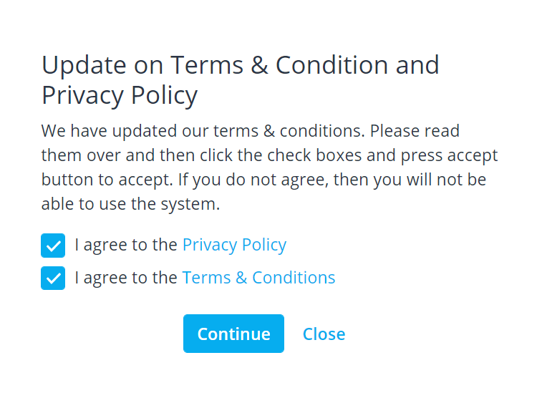
On accessing the accessing the link, a pop up message will appear, confirming if you would like to set a new password. Click ‘Continue’
A pop-up for Terms and Condition privacy policy:

If you agree to the terms, check the boxes and click ‘Continue’
When prompted, enter your new password when prompted. Passwords must fulfil the following criteria:
- Be at least 15 characters long
- Contain at least 1 x Upper and 1 x Lower character
- Contain at least one numerical or special character (e.g. $%*&)
  - Log In Success
On accessing the booking system after your first log in you will be directed to the welcome page:
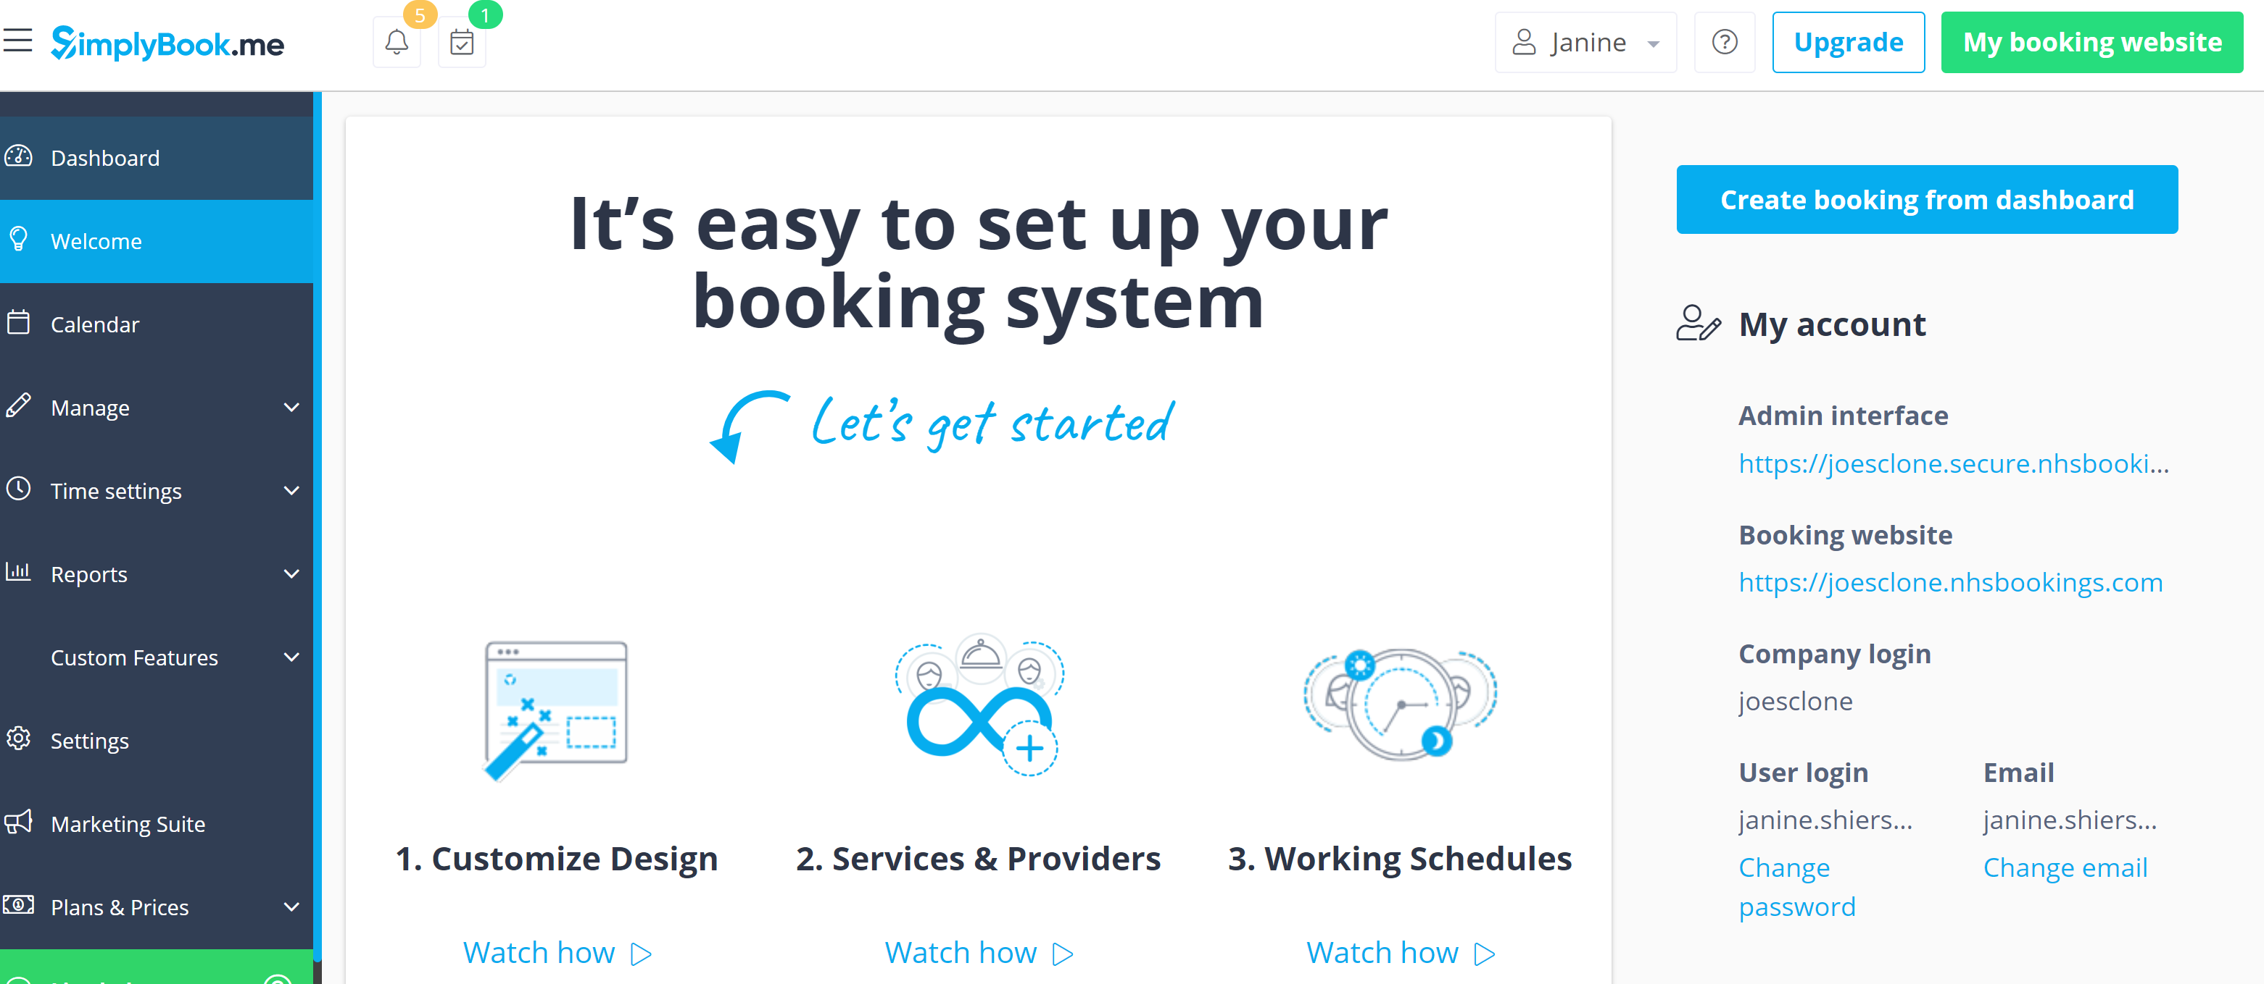
  - Log Out
Once you have finished a session you must log out of the system.
To do this click on the drop down box in the top right hand corner of the screen where your name is displayed, and select ‘Log Out’
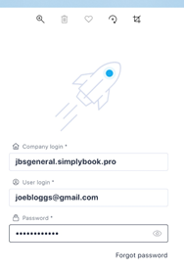
- Accessing the Simplybook App for the First time
  - Accessing the app
Open up the Simplybook App
You should now see a screen with a rocket on it.
Enter the following information to log you in:
Company login = this is the ‘admin interface url’ (you must remember this company login, it will be needed each time you log in)
Username = your username as indicated in your welcome email
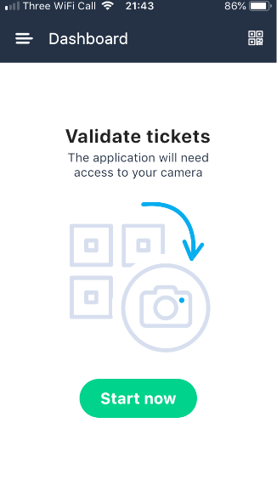
Password = your password
  - Log In Success
Once you have successfully entered the system, you will be directed to the dashboard screen ready to begin scanning tickets, by clicking ‘Start now’
  - Log Out
Once you have finished a session you must log out of the system. To do this click on the three line icon in the top left hand corner of the screen, and select ‘Log Out’
- Points to consider
  - Selecting the most appropriate interface
The Simplybook App is designed to streamline the doorman function, as their role is to validate booking tickets of patients on arrival into clinic.
It can be used by the other account users, however not all the functionality required to perform their role is supported by the app.
  - Requesting a password reset
Should you have forgotten click on the ‘forgot password’ link at the log in screen, or contact your account administrator for support. If you are the clinic’s system administrator, please contact
  - Remember to Log out of the System
You must always ensure that you log out of the system at the end of your shift.
If you do not do this, then you will remain logged in, and other Service Providers may use your log in details to record their work.
It is therefore your responsibility to log yourself out of the system at the end of you shift. Click on settings and click ‘log out

