User Management for the Simplybook Booking Platform
To support the Covid-19 vaccination delivery
Contents
1 Definition and Purpose 3
2 Access Level Required 3
2.1 Access Level 3
3 Adding A New User 3
3.1 Information Required. 3
3.2 Adding a new user 3
4 Resend the Access Link Email 4
4.1 Resend Access Link 4
5 Password Reset 5
5.1 User password reset 5
6 Amending Access Level 5
6.1 Changing the access level of a user 5
7 Deleting a User 6
7.1 Deleting a single user account 6
7.2 Deleting a single user account Deleting multiple user accounts 6
7.3 Restricting access for an Administrator account 6

- Definition and Purpose
This booklet sets out the operational processes for managing user profiles in the Simplybook platform.
Should you not be able to find the support you require within this document, please contact the jbs.enquiries@miaa.nhs.uk mailbox, where one of the team will be able to assist.
- Access Level Required
  - Access Level
Only users with ‘Administrator’ level accounts are able to access the ‘Manage User’ function in Simplybook which is required for adding and amending users
- Adding New Users
- Amending the access level of existing users
- Password resets
- Removal of users (with the exception of users set with admin level access)
- Adding A New User
  - Information Required.
New users for the system request access need to provide the following information:
- Full Name
- Email Address
- Contact Mobile Number
- Type of access – i.e. Administrator, POS, Doorman
  - Adding a new user
Using your account details, open your (admin interface) Simplybook, and on the side bar menu of Simplybook, click on ‘Manage’ and then ‘Users’
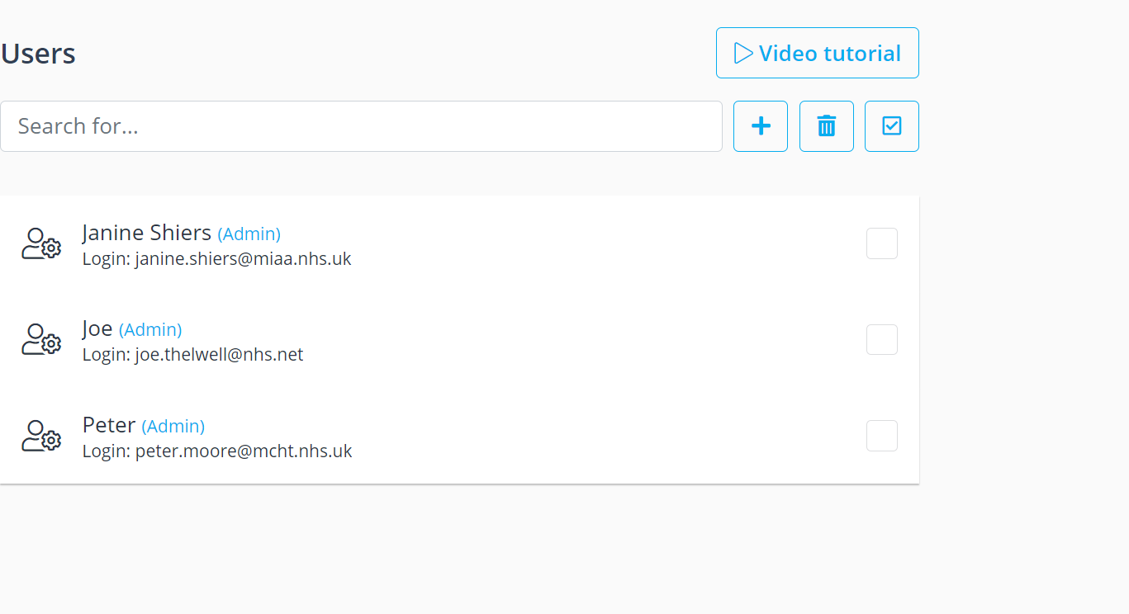
Click on the ‘+’ icon
A new pop up box will appear on the right-hand side for you to enter the new user details:
- Using the information provided, complete all mandatory fields (*)
- Passwords must fulfil the following criteria:
- Be at least 10 characters long
- Contain at least 1 x Upper and 1 x Lower character
- Contain at least one numerical or special character (e.g. $%*&)
- Select the appropriate job role:
- Doorman
- POS
- Admin (note admin users cannot be deleted)
- Enable ‘Send Login Information to user’
- Click on ‘Save and Close’
- The new user will receive a system generated email with their username, and a link to access the system and reset their own password. The link will be active for 3 hours. If a user does not access the link in this time, a new link will need to be sent.
- Resend the Access Link Email
  - Resend Access Link
The link in the new user email is valid for 3 hours. If a new user attempts to complete access after this time, a new link will need to be sent.
Using your account details, open your (admin interface) Simplybook, and on the side bar menu of Simplybook, click on ‘Manage’ and then ‘Users’
- From the list of users, find the user who requires a new account link to be sent
- Click on the user, and on the right-hand side of the screen you will see their account details.
- Scroll down until you see the ‘Send Login Information to user’
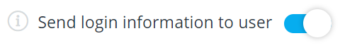
- Enable this by sliding the button to turn it blue
- Click on ‘Save and Close’
- This will send the user a new system generated email with their username, and a link to access the system and reset their own password.

- Password Reset
  - User password reset
Using your account details, open your (admin interface) Simplybook, and on the side bar menu of Simplybook, click on ‘Manage’ and then ‘Users’
- From the list of users, find the user who requires their password to be reset
- Click on the user, and on the right-hand side of the screen you will see their account details.
- Enter a new password – passwords must fulfil the following criteria:
- Be at least 10 characters long
- Contain at least 1 x Upper and 1 x Lower character
- Contain at least one numerical or special character (e.g. $%*&)
- Scroll down until you see the ‘Send Login Information to user’
- Enable this by sliding the button to turn it blue
- Click on ‘Save and Close’
- This will send the user a new system generated email with their username, and a link to access the system and reset their own password.
- Amending Access Level
  - Changing the access level of a user
It is possible to change the access level of a user, and increase or decrease their level of system access. The exception is for users with ‘Admin’ level access, as they cannot be downgraded.
Using your account details, open your (admin interface) Simplybook, and on the side bar menu of Simplybook, click on ‘Manage’ and then ‘Users’
- From the list of users, find the user who requires their access level to be amended.
- Click on the user, and on the right-hand side of the screen you will see their account details.
- Under ‘Group’ select the new job role:
- Doorman
- POS
- Admin (note admin users cannot be deleted)
- Click on ‘Save and Close’

- Deleting a User
It is possible to delete a user’s account, with the exception of those users with ‘Admin’ level access. In the case of ‘Administrators’ access can only be restricted.

  - Deleting a single user account
Using your account details, open your (admin interface) Simplybook, and on the side bar menu of Simplybook, click on ‘Manage’ and then ‘Users’
- From the list of users, find the user who requires their account to be deleted.
- Click on the user, and on the right-hand side of the screen you will see their account details.
- Click ‘Delete’
- A pop-up will appear ‘Are you sure you want to delete current element?’ Click ‘Yes’

  - Deleting a single user account Deleting multiple user accounts
Using your account details, open your (admin interface) Simplybook, and on the side bar menu of Simplybook, click on ‘Manage’ and then ‘Users’
- From the list of users, select the users who need their accounts deleting by checking the box.
- Once all users to be deleted have been selected, click on the bin icon
- Click ‘Delete’
- A pop-up will appear ‘Are you sure you want to delete current element?’ Click ‘Yes’

  - Restricting access for an Administrator account
Using your account details, open your (admin interface) Simplybook, and on the side bar menu of Simplybook, click on ‘Manage’ and then ‘Users’
- From the list of users, find the admin level user who requires their account to be restricted.
- Click on the user, and on the right-hand side of the screen you will see their account details.
- Click ‘Change Password’
- Enter a new password – passwords must fulfil the following criteria:
- Be at least 10 characters long
- Contain at least 1 x Upper and 1 x Lower character
- Contain at least one numerical or special character (e.g. $%*&)
- Click on ‘Save and Close’

