# 

Validating Tickets on the Simplybook Booking Platform

To support the Covid-19 vaccination delivery

Contents

1 Definition and Purpose 3

2 Validating a Ticket 3

2.1 Validating a ticket using the Simplybook mobile app 3

2.2 Validating a ticket using the admin interface (using a website link) 3

2.3 Validating a ticket where the users arriving without their booking ticket 4

1. Definition and Purpose

This booklet sets out the operational processes for validating a booking made on the JBS Booking Platform, confirming the user’s attendance in clinic.

Should you not be able to find the support you require within this document, please contact the [jbs.enquiries@miaa.nhs.uk](mailto:jbs.enquiries@miaa.nhs.uk) mailbox, where one of the team will be able to assist.

1. Validating a Ticket
   1. Validating a ticket using the Simplybook mobile app

**For users with Doorman access and above.**

Open the mobile app.

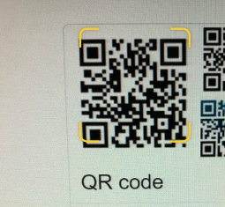From the Dashboard screen on the Service Phone Device click on the square barcode icon at the top of the screen (next to the magnifying glass). Using the camera function of the mobile device, scan the QR code on the ticket

When the code is recognised, you will be asked if you want to validate the appointment – make sure that you do validate the appointment.

In the event that you need to enter the ticket number manually you can do this by clicking on the scan icon and select ‘enter manually’:

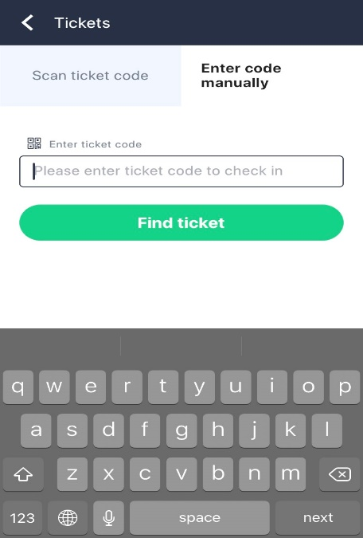

* 1. Validating a ticket using the admin interface (using a website link)

**For users with Doorman access and above**

Open your Simplybook account.

Select **Calendar** from the sidebar menu, and then **Validate Ticket**.

Enter the ticket number (or scan using a QR code readable scanner) into the search bar, and click ‘**Find Ticket**’

Scroll to the bottom of the screen, where the booking details will appear:

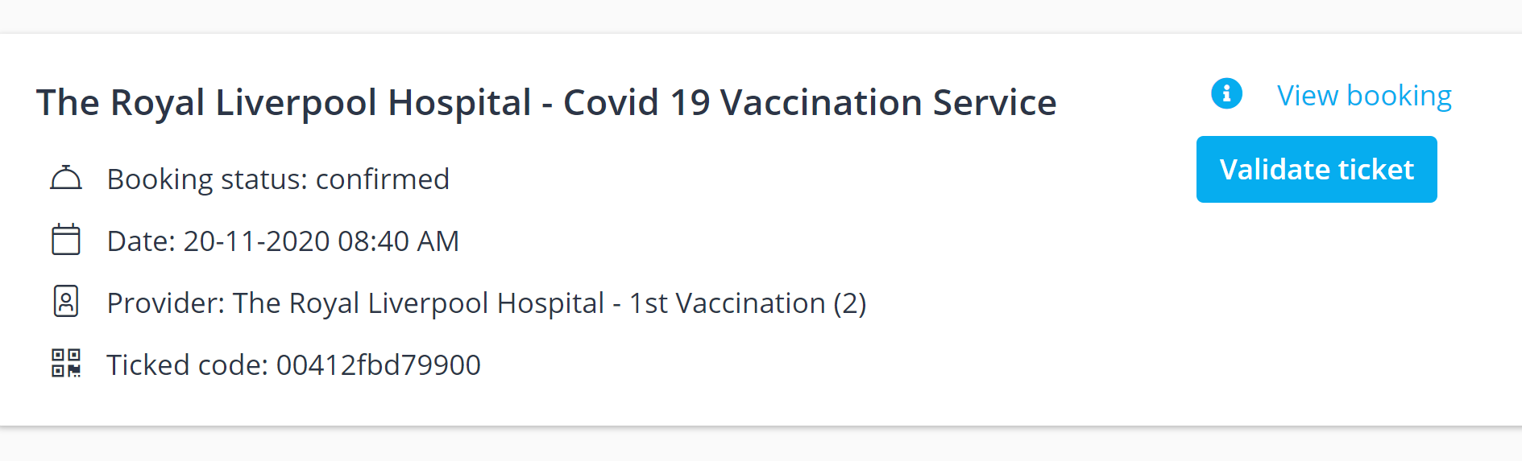

Click ‘**Validate Ticket**’

* 1. Validating a ticket where the users arriving without their booking ticket

**For users with POS access and above.**

Open your Simplybook account from the admin interface (using a website link).

Select **Calendar** from the sidebar menu

Locate the booking from the calendar screen by using the mouse cursor to hoover over the entries to produce a pop up with the booking details:

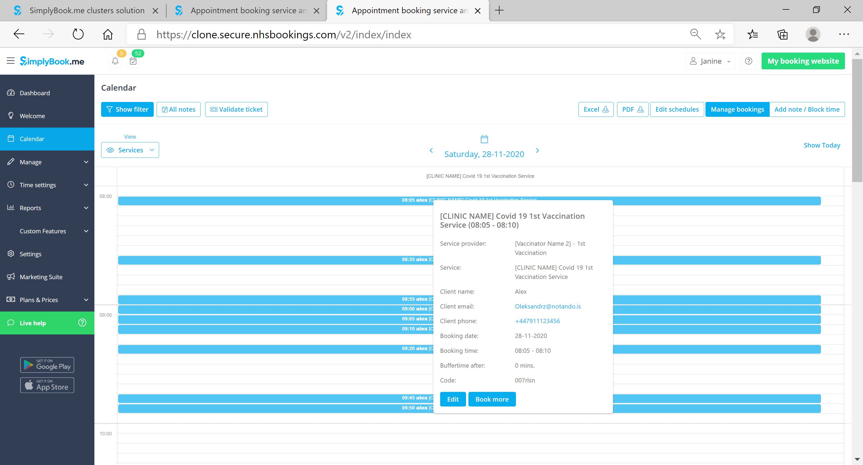

Make a note of the booking code – you can copy the code (hold down the left mouse button and highlight the number in full, then right click and ‘copy’)

Click on ‘**Validate Ticket**’

Enter the booking code (or right click and ‘paste’)

‘**Find Ticket**’

Scroll to the bottom of the screen, where the booking details will appear:



Click ‘**Validate Ticket**’