Amending a Service on the Simplybook Booking Platform
To support the Covid-19 vaccination delivery
Contents
1 Definition and Purpose 3
2 Considerations before amending 3
2.1 Service Name 3
2.2 Appointment Times 3
2.3 Visibility 3
2.4 Adding New Services 3
3 Amending a Service Name 3
3.1 Changing the name of a service 3
3.2 Amending the service schedule 4
3.3 Setting Special Days 4
4 Deleting a Service 5
4.1 Deleting a Service 5

- Definition and Purpose
This booklet sets out the operational processes for amending a service set up for a clinic. Each clinic has been set with a single service.
Should you not be able to find the support you require within this document, please contact the jbs.enquiries@miaa.nhs.uk mailbox, where one of the team will be able to assist.
- Considerations before amending
  - Service Name
The name of the service is a data field that is displayed on the booking website, as well as the booking tickets that users are provided with when they book an appointment.
The default is set to [Clinic Name] – Covid 19 Vaccination Service.
  - Appointment Times
The default setting for the service is set to 10 minutes. This is to allow 5 minutes for a vaccination, and to accommodate the second appointments. Once appointments have been made, it is not possible to change the timeslots setting. If you would like to set up an extended appointment vaccination lane, then this should be accomplished using a new service.
  - Visibility
In order for users to book the service, the service needs to be visible on the website (open eye symbol).
  - Adding New Services
Each Service need to have Service Providers associated to it. When adding a Service, be sure to add Service Providers. If the new service is to accommodate extended appointments, and you want to restrict access to those in need, then do not make the service visible (closed eye symbol).
- Amending a Service Name
  - Changing the name of a service
For users with Admin access.
Open your Simplybook account from the admin interface (using a website link).
Select Manage from the sidebar menu, and the ‘Service’
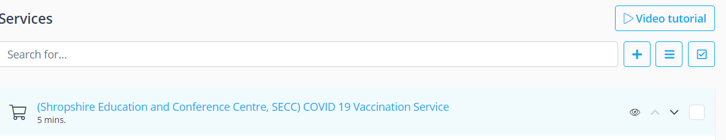
Select the service, and click on the name
This will bring up the details of the service on the right-hand side.
Click on the name of the service field and amend.
Once amended, click ‘Save & Close’.
  - Amending the service schedule
Where only one service exists, the schedule should match the companies opening hours. If more than one service exists, then the schedule can be customised.
For users with Admin access.
Open your Simplybook account from the admin interface (using a website link).
Select Manage from the sidebar menu, and the ‘Service’
Click on the service to be amended, and scroll down to the Service Schedule
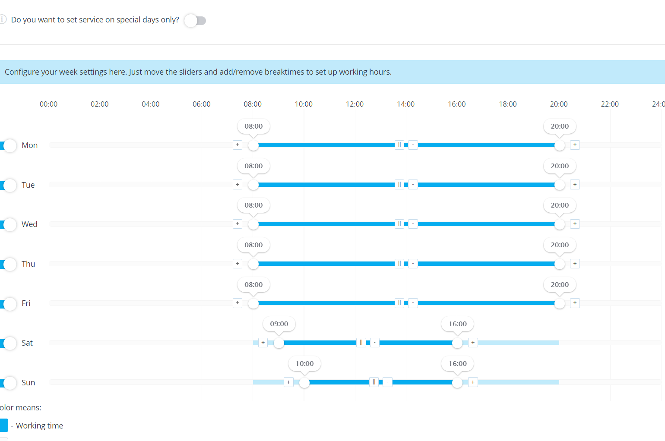
Using the slider, adjust your service opening hours to suit.
Once you have finished editing, click ‘Save & Close’
  - Setting Special Days
In instances where you need to set a special day, for example ad hoc closure of the service, or reduced hours, this should be accomplished using the Special Days function. For changes to the clinics operational hours, this should be done at ‘company’ level, if there is more than one service.
For users with POS access and above.
Open your Simplybook account from the admin interface (using a website link).
Select Time Settings from the sidebar menu, and then ‘Providers Schedule’, and then ‘Special Days Schedule’
Select the date on the calendar and pop-up will appear to allow you to make changes
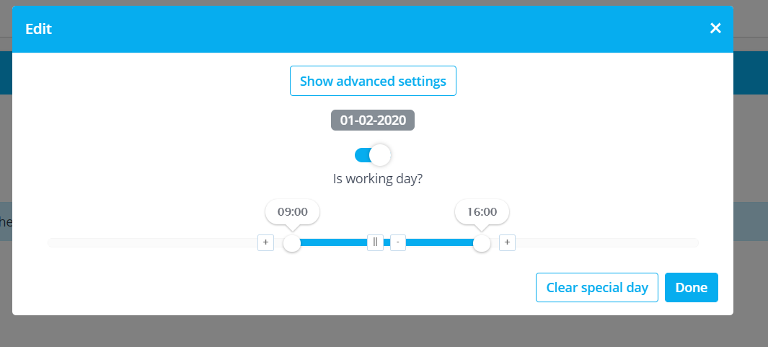
When you have finished editing, click ‘Done’
The date amended now appears highlighted yellow on the calendar.
- Deleting a Service
If a service has been created in error, it can be deleted, provided no bookings have been associated with it. Where bookings have been made, the service should be hidden instead, by changing the visibility
  - Deleting a Service
For users with Admin access.
Open your Simplybook account from the admin interface (using a website link).
Select ‘Manage’ from the sidebar menu, and the ‘Service’
Select the Service to be deleted, by checking the box
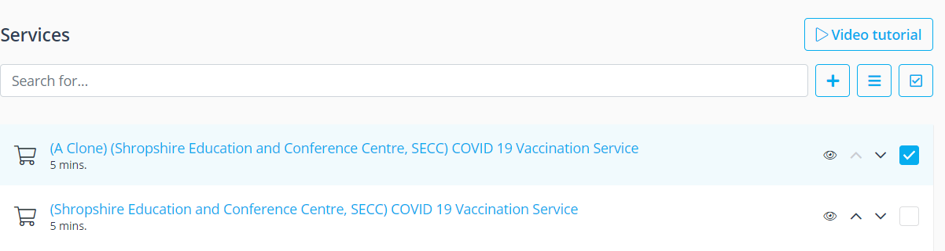
Click the three line menu icon, and select ‘delete’
A pop-up box will ask ‘Are you sure you want to delete selected elements?’, click ‘OK’

