Customising the Simplybook Booking Platform
To support the Covid-19 vaccination delivery
Contents
1 Definition and Purpose 3
2 Email Notifications 3
2.1 Customising email notification 3
3 Company Hours 3
3.1 Opening Hours 3
3.2 Setting Special Calendars 4

- Definition and Purpose
This booklet sets out the operational processes for customising your Simplybook account, which will be visible on the booking page, and will customise the experience your users receive.
Should you not be able to find the support you require within this document, please contact the jbs.enquiries@miaa.nhs.uk mailbox, where one of the team will be able to assist.
- Email Notifications
  - Customising email notification
The default setting for email notifications, is for Booking Confirmations, Cancellation Notifications and Reminders. Due to the number of updates a booking undergoes as part of the system update, the ‘Change Notification’ email is not activated.
The email works using a mail merge function.
For users with Admin access.
Open your Simplybook account from the admin interface (using a website link).
Click ‘Settings’, then ‘Email and SMS settings’
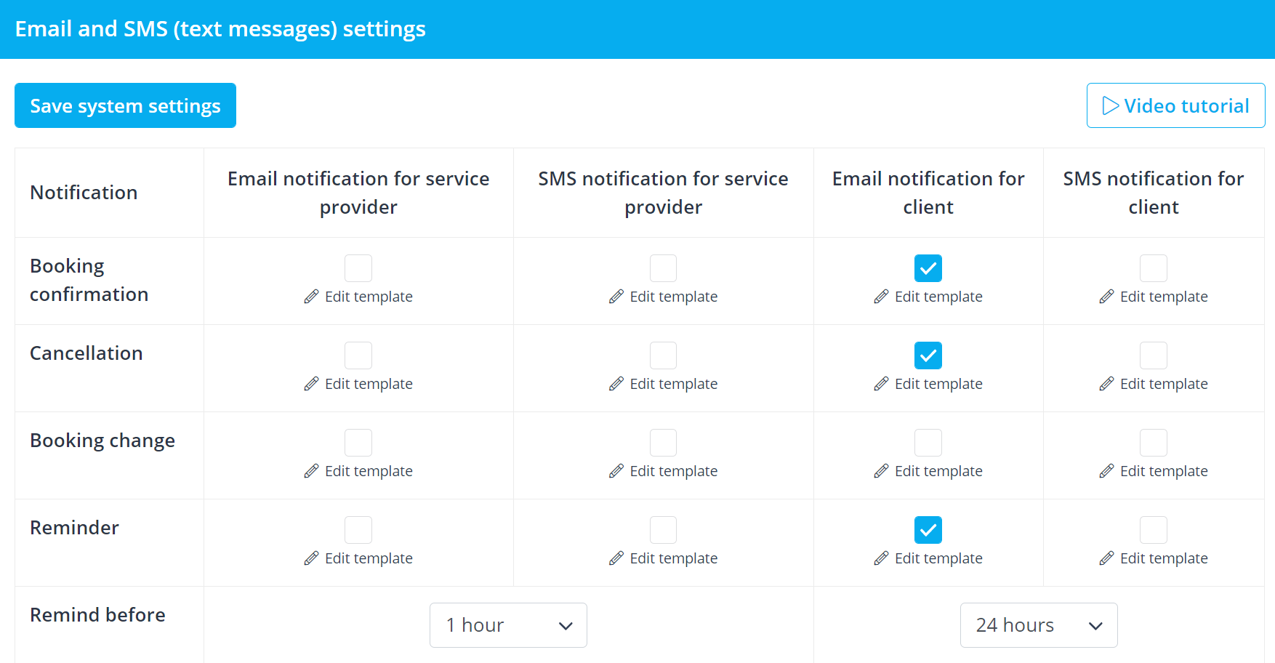
To amend the time setting for the reminder (default is 24 hours)
To amend the content, click ‘Edit Template’
Update the content, and then ‘Save system settings’
- Company Hours
  - Opening Hours
For users with Admin access.
Open your Simplybook account from the admin interface (using a website link).
Select ‘Time Settings’ from the sidebar menu, and the ‘Company Opening Hours’
Make the required changes to the schedule, ensure that no current bookings will be impacted by the change.
Amendments are saved automatically.
  - Setting Special Calendars
For users with Admin access.
Open your Simplybook account from the admin interface (using a website link).
Select ‘Time Settings’ from the sidebar menu, and the ‘Company Opening Hours’, and then ‘Special Days Schedule’

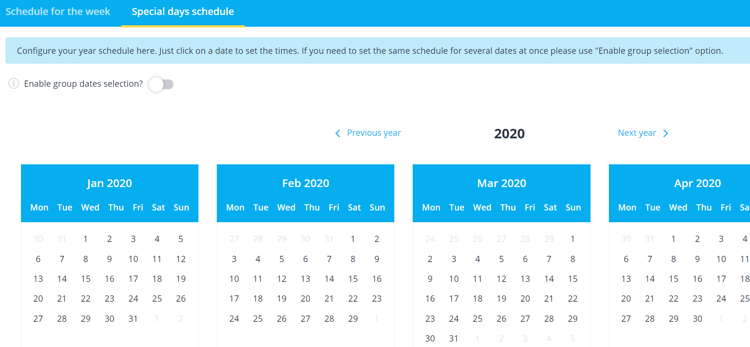
Select the date on the calendar and pop-up will appear to allow you to make changes

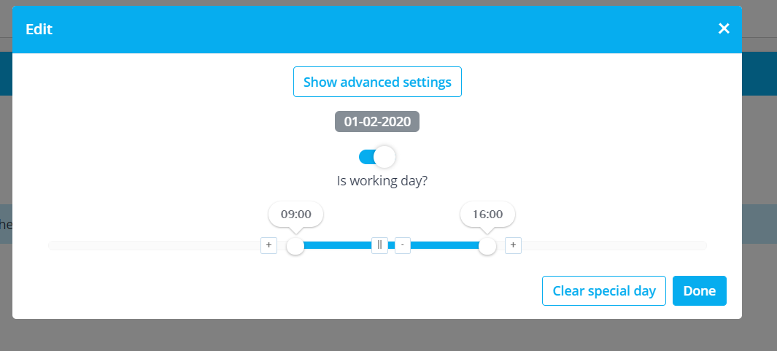
When you have finished editing, click ‘Done’
The date amended now appears highlighted yellow on the calendar.

